Parsons School of Design
School of Art and Design History and Theory
Graphic Design: A History
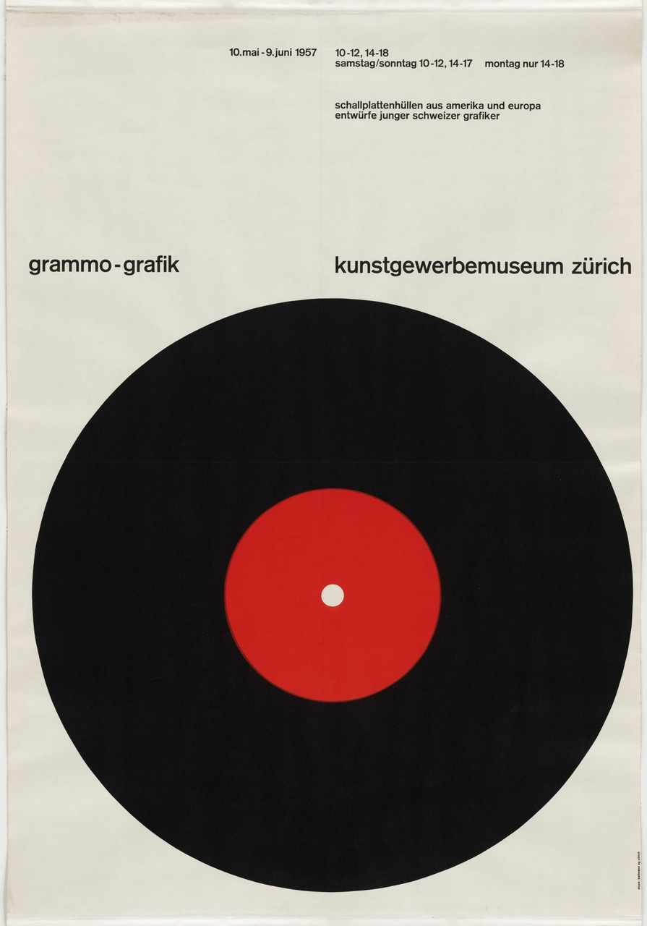
Fall 2015

Wednesdays 12:10 pm–2:50 pm, 6 East 16th Street,
room 1107
PLVS 3023, Section A; CRN 7394

Prof. Ethan Robey
robeye@newschool.edu
212-849-8346

Course Description
This course will survey the major movements in graphic design since the late nineteenth century, and the designers who have significantly contributed to the development of the practice. We will discuss design within the context of political, social and art history, and consider the effects of various technological changes.

Course Outline

Sept. 2 | Introduction: materials and methods  The 19th C.: The woodtype era and the beginnings of mass culture  Readings:  Philip Meggs, A History of Graphic Design (4th ed.), Ch. 9. “Graphic Design and the Industrial Revolution.”  Pocket Pal: A Graphic Arts Production Handbook, pp. 28-33, 38-44, 48-51.

Sept. 9 | The Arts and Crafts Movement in England; Art Nouveau I  Readings:  William Morris, “The Ideal Book” (1893), in Michael Bierut et al, eds. Looking Closer 3: Classic Writings on Graphic Design, pp. 1-5.  Meggs, Ch. 10. “The Arts and Crafts Movement and its Heritage.”  Stephen Eskilson, Graphic Design: A New History, pp. 35-49, 58-68.

Sept. 16 | Art Nouveau II  Readings:  Steven Heller, Merz to Émigré, and Beyond: Avant-Garde Magazine Design of the Twentieth Century, pp. 17-18, 28-31.  Eskilson, pp. 49-57, 72-105.

Sept. 23 | No class meeting (Yom Kippur)

Sept. 30 | The Object Poster; Graphic Design of World War I  Readings:  Heller, Design Literacy: Understanding Graphic Design, pp. 239-241 (Priester Match Poster).  Eskilson, pp. 108-132.

Oct. 7 | In-Class Exam  Futurism  Readings:  F.T. Marinetti, “The Foundation and Manifesto of Futurism” (1909).  Meggs, Ch. 13. “The Influence of Modern Art,” pp. 248-256.

Oct. 14 | Dada; Constructivism  Readings:  Meggs, Ch. 13. “The Influence of Modern Art,” pp. 256-264.  Meggs, Ch. 15. “A New Language of Form.”  Heller, Merz to Émigré, pp. 50-67, 71-80, 89-93.

Oct. 21 | The Bauhaus and the “New Typography”  Readings:  Herbert Bayer, “Towards a Universal Type” (1935), in Looking Closer 3, pp. 60-62.  Mike Mills, “Herbert Bayer’s Universal Type in its Historical Context,” in  The ABC’s of , pp. 38-45.  Aynsley, Graphic Design in Germany, pp. 94-111, 169-172.

Oct. 28 | Bauhaus (continued); Art Déco Style  Readings:  Eskilson, pp. 170-183.

Nov. 4 | Graphics of World War II  Readings:  Meggs, Ch. 17. “The Modern Movement in America,” pp. 342-352.  Heller, Design Literacy, pp. 199-201 (The Swastika).  Aynsley, Graphic Design in Germany, 179-191.

Nov. 11 | Swiss International Style  Readings:  Emil Ruder, “The Typography of Order” (1959), in Looking Closer 3, pp. 135-138.  Meggs, Ch. 18. “The International Typographic Style.”

Nov. 18 | Corporate Identity & American Modernism  Readings:  Jessica Helfand, “Logocentrism,” (1997) on Design Observer  Martha Scotford, “Cipe Pineles,” in Graphic Design History, pp. 161-166.  Leslie Savan, “This Typeface is Changing Your Life” (1976), in Looking Closer 3, pp. 256-259.  Meggs, Ch. 19. “The New York School.”

Nov. 24 (Note TUESDAY) | Counter-culture and Revolution: Paris, London, San Francisco and New York  Readings:  Jean-Pierre Criqui, “The Poster on Fire: Creating the Psychedelic Aesthetic,” in Gastaut and Criqui, Off the Wall: Psychedelic Rock Posters from San Francisco, pp. 13-32.  Heller, Merz to Émigré, pp. 182-194.

Nov. 25 | No class meeting (Thanksgiving)

Dec. 2 | Postmodernism  Readings:  Poynor, No More Rules: Graphic Design and Postmodernism, pp. 18-37.  Heller, Merz to Émigré, pp. 200-205, 208-223.

Dec. 9 | Digital Design and Contemporary Design Practice  Readings:  Eskilson, pp. 352-369.  Optional: Meggs, Ch. 24. “The Digital Revolution and Beyond.”

Dec. 16 | In-Class Final Exam

Learning Outcomes
By the successful completion of this course, students will be able to:
- Demonstrate knowledge major movements, designers and significant pieces of late nineteenth- and twentieth-century graphic design.
- Situate design in historical, social and stylistic contexts.
- Conduct research on graphic design and designers.

Assessable Tasks
Midterm examination; Final examination; Research project.

Course Requirements % of Grade
Attendance/preparation/participation 20%
Midterm exam 30%
Research assignment/presentation 20%
Final exam 30%

Required Reading
Selections are indicated in the course schedule, above. Readings will be made available though the course Canvas site. The following books will also be on reserve for the class in the University Center Library:

Philip Meggs, A History of Graphic Design (4th ed., Hoboken, N.J.: J. Wiley & Sons, 2006).
Stephen Eskilson, Graphic Design: A New History (New Haven: Yale University Press, 2007/2012).

Grading Standards

A [4.0; 96–100%]
Work of exceptional quality, which often goes beyond the stated goals of the course
A- [3.7; 91 –95%]
Work of very high quality
B+ [3.3; 86–90%]
Work of high quality that indicates substantially higher than average abilities
B [3.0; 81–85%]
Very good work that satisfies the goals of the course
B- [2.7; 76–80%]
Good work

C+ [2.3; 71–75%]
Above-average work

C [2.0; 66–70%]
Average work that indicates an understanding of the course material; passable
Satisfactory completion of a course is considered to be a grade of C or higher.
C- [1.7; 61–65%]
Passing work but below good academic standing
D [1.0; 46–60%]
Below-average work that indicates a student does not fully understand the assignments;
Probation level though passing for credit

F [0.0; 0–45%]
Failure, no credit

Grade of W
The grade of W may be issued by the Office of the Registrar to a student who officially withdraws from a course within the applicable deadline. There is no academic penalty, but the grade will appear on the student transcript.
Grade of WF
The grade of WF is issued by an instructor to a student who has not attended or not completed all required work in a course but did not officially withdraw before the withdrawal deadline. It differs from an “F,” which would indicate that the student technically completed requirements but that the level of work did not qualify for a passing grade. The WF is equivalent to an F in calculating the grade point average (zero grade points), and no credit is awarded.
Grades of Incomplete
The grade of I, or temporary incomplete, may be granted to a student under unusual and extenuating circumstances, such as when the student’s academic life is interrupted by a medical or personal emergency. This mark is not given automatically but only upon the student’s request and at the discretion of the instructor. A Request for Incomplete form must be completed and signed by student and instructor. The time allowed for completion of the work and removal of the “I” mark will be set by the instructor with the following limitations:

Undergraduate students: Work must be completed no later than the seventh week of the following fall semester for spring or summer term incompletes and no later than the seventh week of the following spring semester for fall term incompletes. Grades of “I” not revised in the prescribed time will be recorded as a final grade of “WF” by the Office of the Registrar.

Class Policies

Responsibility
Students are responsible for all assignments, even if they are absent. Late assignments, failure to complete the assignments for class discussion and/or critique, and lack of preparedness for in-class discussions, presentations and/or critiques will jeopardize your successful completion of this course.

Participation
Class participation is an essential part of class and includes: keeping up with reading, assignments, projects, contributing meaningfully to class discussions, active participation in group work, and coming to class regularly and on time.

Attendance
Faculty members may fail any student who is absent for a significant portion of class time. A significant portion of class time is defined as three absences for classes that meet once per week and four absences for classes that meet two or more times per week. During intensive summer sessions a significant portion of class time is defined as two absences. Lateness or early departure from class may also translate into one full absence.

Canvas
Students should check Canvas for assignment ad and announcements each week.

Delays
In rare instances, I may be delayed arriving to class. If I have not arrived by the time class is scheduled to start, you must wait a minimum of thirty minutes for my arrival. In the event that I will miss class entirely, a sign will be posted at the classroom indicating your assignment for the next class meeting.

Electronic Devices
Use of electronic devices (phones, tablets, laptops) is permitted when the device is being used in relation to the course's work. All other uses are prohibited in the classroom and devices should be turned off before class starts. That is, you can take notes on your laptop during class but not look at Facebook.

Academic Honesty and Integrity
The New School views “academic honesty and integrity” as the duty of every member of an academic community to claim authorship for his or her own work and only for that work, and to recognize the contributions of others accurately and completely. This obligation is fundamental to the integrity of intellectual debate, and creative and academic pursuits. Academic honesty and integrity includes accurate use of quotations, as well as appropriate and explicit citation of sources in instances of paraphrasing and describing ideas, or reporting on research findings or any aspect of the work of others (including that of faculty members and other students). Academic dishonesty results from infractions of this “accurate use”. The standards of academic honesty and integrity, and citation of sources, apply to all forms of academic work, including submissions of drafts of final papers or projects. All members of the University community are expected to conduct themselves in accord with the standards of academic honesty and integrity. Please see the complete policy in the Parsons Catalog.

It is the responsibility of students to learn the procedures specific to their discipline for correctly and appropriately differentiating their own work from that of others. Compromising your academic integrity may lead to serious consequences, including (but not limited to) one or more of the following: failure of the assignment, failure of the course, academic warning, disciplinary probation, suspension from the university, or dismissal from the university.

Student Disability Services (SDS)
In keeping with the University’s policy of providing equal access for students with disabilities, any student with a disability who needs academic accommodations is welcome to meet with me privately. All conversations will be kept confidential. Students requesting any accommodations will also need to meet with Jason Luchs in the Office of Student Disability Services, who will conduct an intake, and if appropriate, provide an academic accommodation notification letter to you to bring to me. SDS assists students with disabilities in need of academic and programmatic accommodations as required by the Americans with Disabilities Act of 1990 (ADA) and Section 504 of the Federal Rehabilitation Act of 1973. http://www.newschool.edu/studentservices/disability/.

