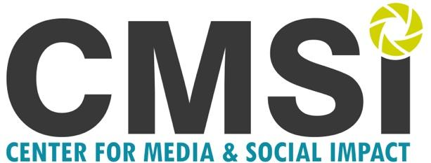 Community Voice Project

The Community Voice Project (CVP), born of American University Filmmaker-in-Residence Nina Shapiro-Perl’s Community Storytelling course, is an initiative of the Center for Media and Social Impact. The Community Voice Project (CVP) connects members of American University’s student population with communities in the Washington Metropolitan area to produce short documentary films, digital stories and reported stories. The CVP partners with a local community organization to focus on a topic and tell the stories most important to that community.

Digital storytelling can take us into the lived experience of community residents not often heard from. In their own words, these stories help break down a sense of “Otherness” from both sides, changing the storyteller and the witness in the process. In its place are people, in all their complexity, with nuanced narratives of segregation, poverty and illness interwoven with beauty, spirituality, connection and hope. This is the transformative potential of the digital story --both in its capacity to effect personal and social change from the side of both storyteller and witness. It allows us to listen deeply to each other, across the divides of neighborhood, class, race and culture, allowing us to connect as people.

The Community Voice Project contains two main components:
- Training with Professor Brigid Maher to become a CMSI Trained Facilitator in Digital Storytelling.
- Story Collection. Participants will then use their newly acquired Digital Storytelling skills to work with individuals selected by the Anacostia Community Museum to tell their own stories of community change.

Digital stories created will be included in public screenings at American University, and with partners, such as, Anacostia Community Museum, and other venues to be determined.

For examples of past work: http://cmsimpact.org/community-voice-project/.

As a CMSI Trained Facilitator in Digital Storytelling, participants can:
- Develop an understanding of one’s own story in order to more effectively connect with collaborators and participants
- Develop effective pathways of communication
- Work with nonprofits to capture participant’s stories
- Develop interviewing skills
- Develop emotional sensitivity when working with community or documentary participants
- Organize and train community storytellers
- Teach community storytelling in educational and community settings.

Ideal Applicants are:
- Interested in giving voice to marginalized communities and exploring inequality in all its forms.
- Interested in working in education at various levels.
- Interested in community building.

Requirements: Video editing skills at an intermediate to advanced level. Intermediate audio and videography skills a plus.

In order to be considered for the Community Voice Project, individuals must submit a completed Application Packet.

Application Packet Requirements:
- A completed application form
- A one (1) page personal statement detailing the following:
  - Why applicant wishes to participate in the program
  - How participation will help in your future career
- One (1) Letter of Reference from someone familiar with your work.
- Five (5) minute work sample
  - Work sample should demonstrate technical and storytelling abilities

Application Due February 15th, 2018.

Applicants will be notified by February 25th, 2018.

Tentative Meeting Dates (subject to change):

Workshop Dates: Partner Storytelling Dates:
March 17th / 18th*:  10am to 4pm | March 31st / April 1st:  10am to 4pm

* Please Note: This is the last weekend of Spring Break*

Questions?
Shannon Shikles, Program Coordinator
ss7235a@student.american.edu
Brigid Maher, Director of CVP and Lead Instructor
bmaher@american.edu

Community Voice Project

Application Due February 15th, 2018. Please submit application by email to Brigid Maher @ bmaher[at]american.edu. In addition to this application, please send a one-page recommendation from a faculty or professional who is familiar with your work.

Applicant Information
Name
Street Address
City, State, Zip Code
Home Phone
Work Phone
E-Mail Address
Program & Year

Special Skills or Qualifications

Summarize special skills and qualifications you have acquired from employment, previous volunteer work, or through other activities.

Work Sample

Please list work sample link below (YouTube or Vimeo):

Agreement and Signature

By submitting this application, I affirm that the facts set forth in it are true and complete. I understand that if I am accepted as a participant, any false statements, omissions, or other misrepresentations made by me on this application may result in my immediate dismissal.
Name (printed)
Signature
Date

